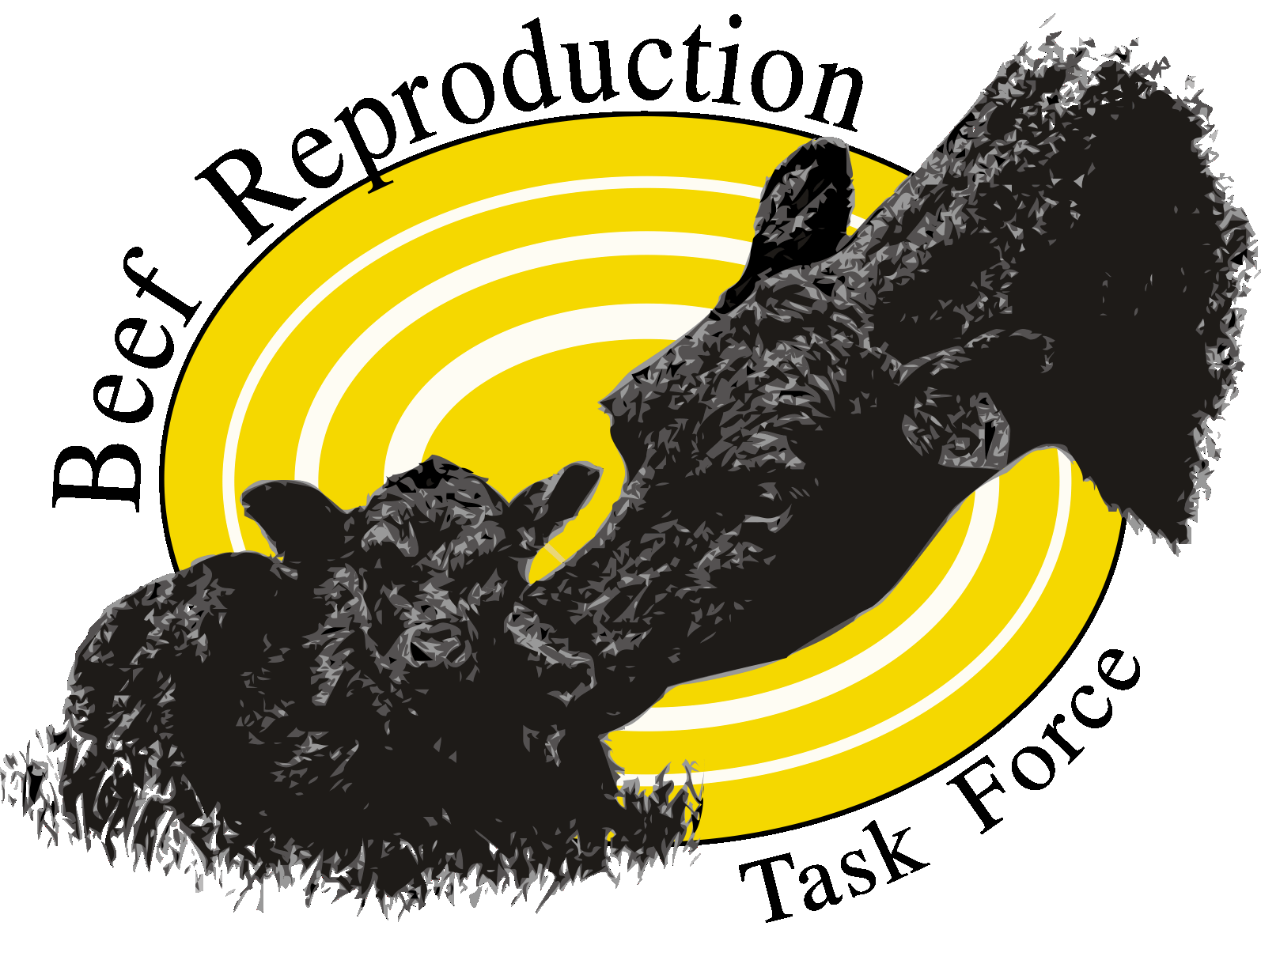
Beef Reproductive Task Force
Service to Industry Award

This award was developed to recognize outstanding contributions by those working in the AI industry towards the application or increased use of AI and estrous synchronization by beef producers. The successful nominee’s work should show strong evidence of efforts towards the goals outlined by the Beef Reproduction Leadership Team. This year one award will be for an outstanding veterinary practice and a second category will be for an AI service technician of a company, or someone working independently with producers to implement AI programs. Individuals may nominate themselves. We will recognize one winner in each category. Announcement of awards will be made in conjunction with the virtual version of ARSBC being planned for 2020. Winner(s) to be awarded a cash prize.

The awards committee will be looking for evidence of:
- Shared success between the nominee and producers served.
- Leadership/support and education to new customers
- Promotion of the value of genetic improvement attainable through AI programs.
- Use of sound research-based recommendations to producers
- Evidence of support of goals of the Beef Reproduction Leadership Team
- Promote wider adoption of reproductive technologies among cow-calf producers.
- Educate cow-calf producers in management considerations that will increase the likelihood of successful AI breeding. (Education in this case is more likely to be one on one or by example)
- Educate producers in marketing options to capture benefits that result from use of improved reproductive technologies.
Directions for submitting a nomination:
1. Submit a maximum of three pages of support answering the questions on the award form cover page. Letters of support (not to exceed 3) from producers may also be submitted.
2. In the first paragraph, list the nominee’s name, title, company, and contact information
3. In the second paragraph list the nominator contact information including phone and e-mail address.
4. Nomination must be submitted by Sept 15, 2020 to Sandy Johnson, sandyj@ksu.edu as an attachment (PDF or Word document)
Beef Reproductive Task Force
Service to Industry Award Form

Submit this cover page and responses to the questions below in no more than 3 pages (one-sided, 12-point font, 1 inch margins). Applications should include three letters of support from producers or others. Award form shall be submitted by Sept 15, 2020 to Sandy Johnson, sandyj@ksu.edu as a Word or PDF document.

Name of Nominee
Title
Company or Business name
Mailing Address
Phone
E-mail

Name of person making nomination
Title
Company or Business name
Mailing Address
Phone
E-mail

- Briefly describe the nominee’s work in the area of AI and estrous synchronization.
- Describe the steps the nominee takes when working with someone who is new to AI or estrous synchronization to help ensure success.
- Briefly tell about a situation where the outcomes of an AI and/or estrous synchronization program was particularly noteworthy.
- Tell about any involvement the nominee has had in helping producers find a strong market for the genetics created from AI projects.

